CASE STUDY

Use Case 1 — E-Commerce Marketplace
You are working as a SQL Developer for ShopKart.
The company wants analytical reports on customers, products, orders, and sellers.

Tables
1. Customers
Column Name | Data Type
customer_id | INT
first_name | VARCHAR
last_name | VARCHAR
city | VARCHAR
signup_date | DATE
referred_by | INT

2. Sellers
Column Name | Data Type
seller_id | INT
seller_name | VARCHAR
city | VARCHAR
rating | DECIMAL
manager_id | INT

3. Products
Column Name | Data Type
product_id | INT
product_name | VARCHAR
category | VARCHAR
seller_id | INT
price | DECIMAL
stock_quantity | INT

4. Orders
Column Name | Data Type
order_id | INT
customer_id | INT
product_id | INT
order_date | DATE
quantity | INT
total_amount | DECIMAL
order_status | VARCHAR
payment_mode | VARCHAR

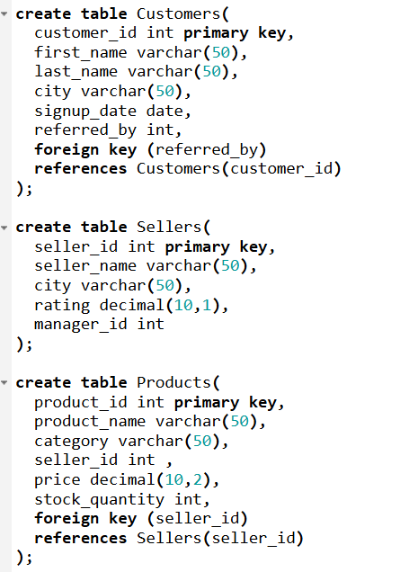
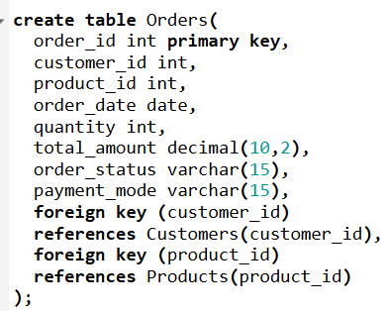
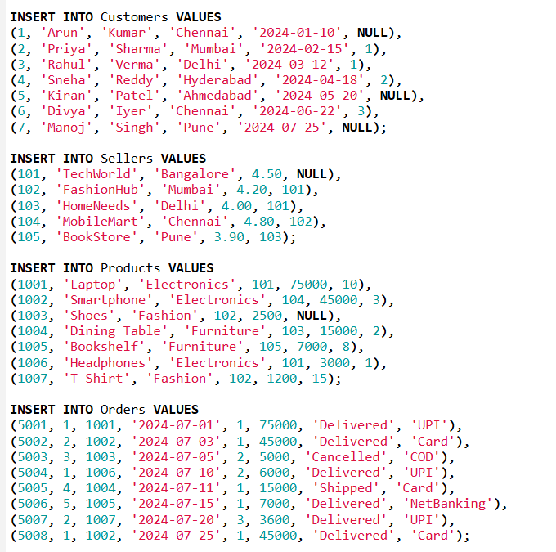
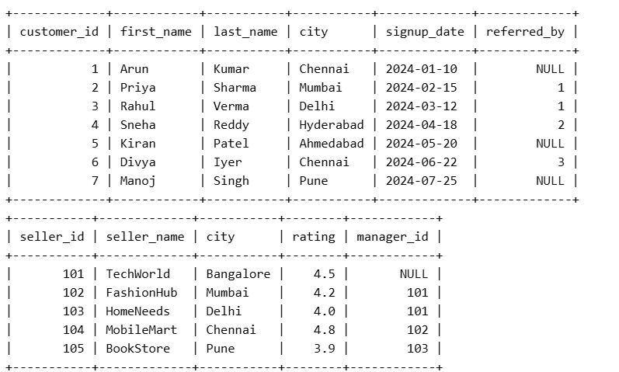
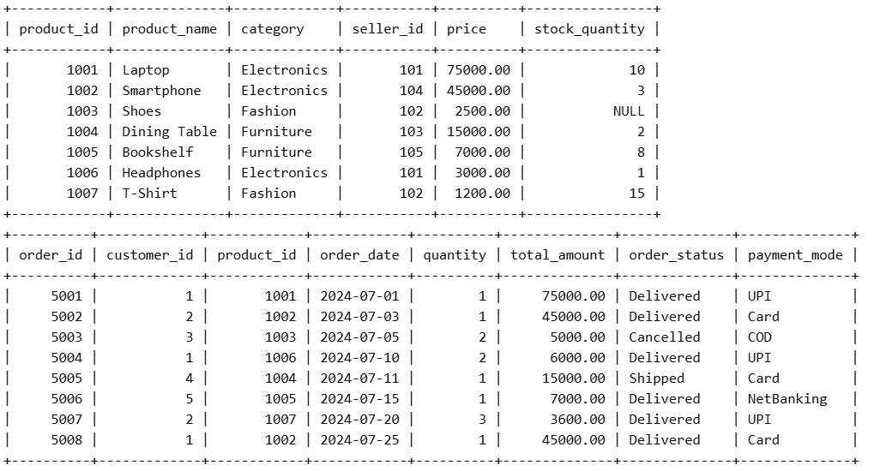

Questions
- Display all products where stock quantity is NULL or less than 5. If stock is NULL, show it as 0.

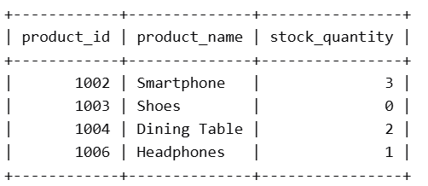

- Display customers who never placed any order.
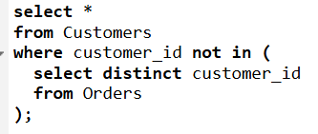
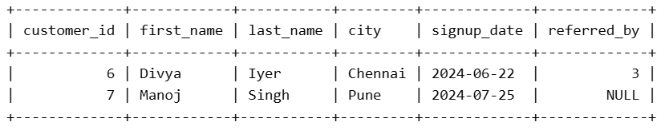

- Compare a customer’s current order amount with their previous order amount and show the difference using window functions.
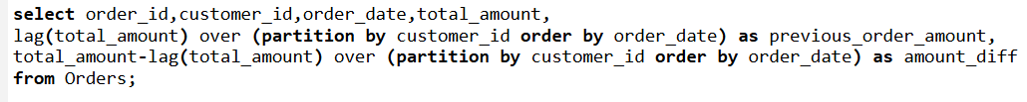
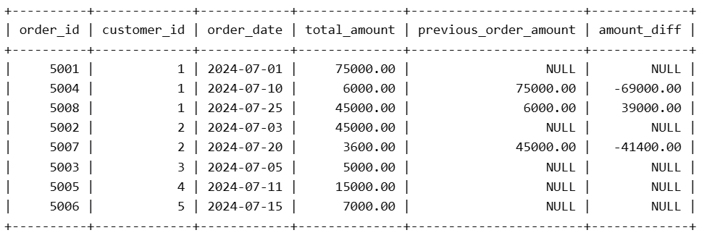

- Use a CTE to find the top 5 customers based on total spending.

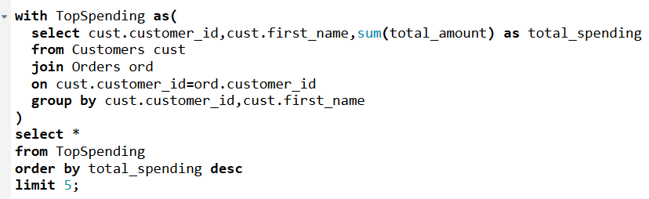
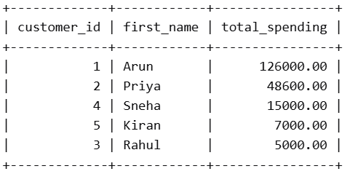

- Find products that were ordered more times than the average number of orders for all products.
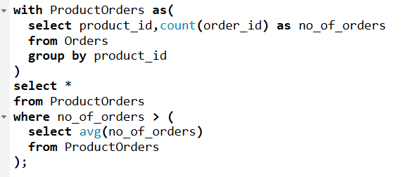
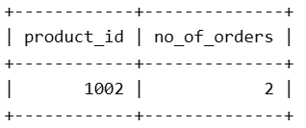

- Create a temp table storing high-value customers who spent more than 50,000 and generate city-wise counts from it.
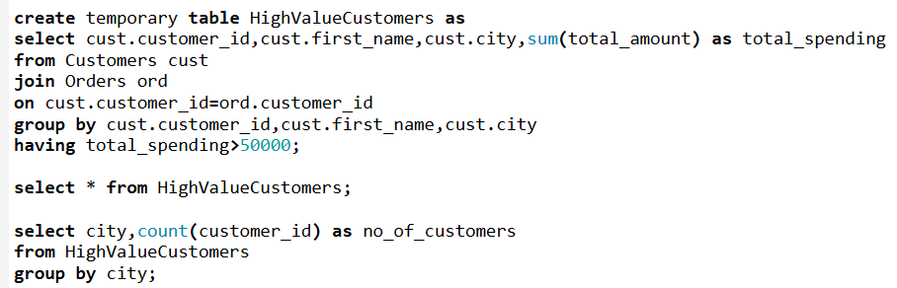
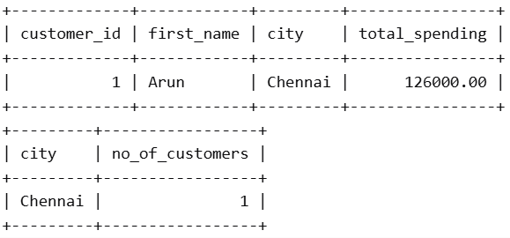

- Use DISTINCT to display unique cities where customers and sellers are located.
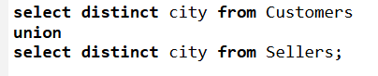
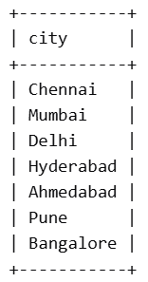

- Write a MERGE statement to update product stock using a newly arrived inventory table.
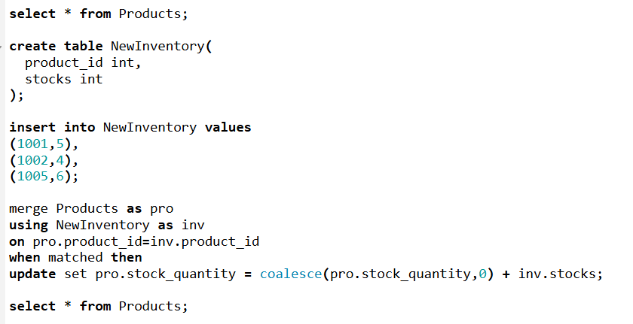
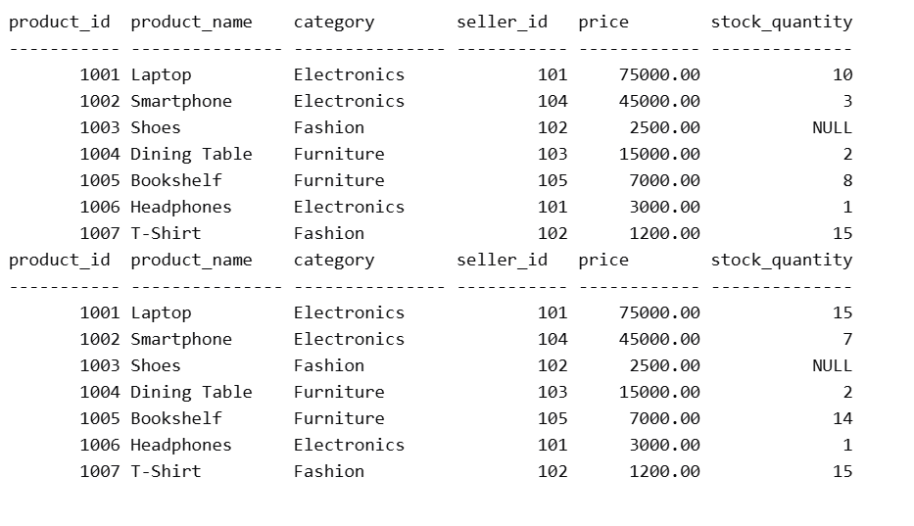

- Create a custom SQL function to calculate discount percentage based on total_amount.
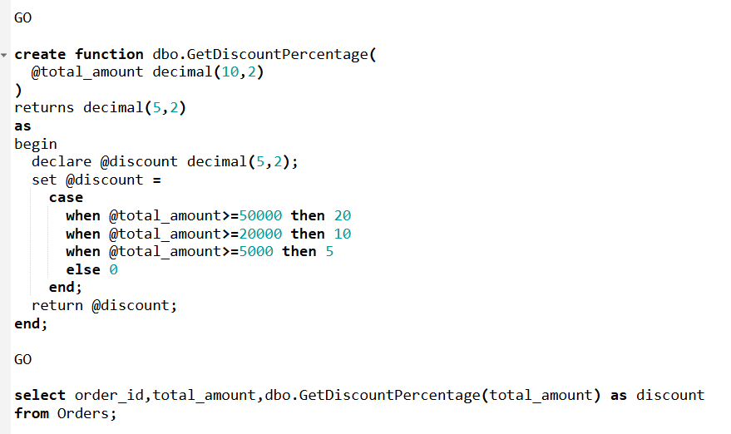
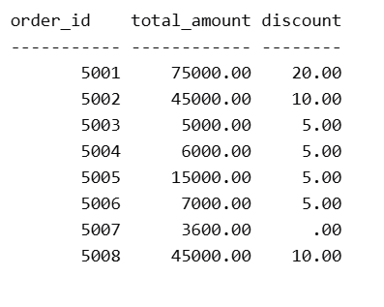

- Suggest query optimization techniques for large order-reporting queries involving joins, filtering, and sorting.
Create Proper Indexes
CREATE INDEX idx_orders_customer
ON Orders(customer_id);
CREATE INDEX idx_orders_product
ON Orders(product_id);
CREATE INDEX idx_orders_date
ON Orders(order_date);

Use Composite Indexes
CREATE INDEX idx_status_date
ON Orders(order_status, order_date);
Avoid Select *
SELECT order_id, customer_id, total_amount
FROM Orders;
Optimize ORDER BY
CREATE INDEX idx_orderdate
ON Orders(order_date DESC);

